**University of the Assumption**

COLLEGE OF ENGINEERING AND ARCHITECTURE

**Computer and Electronics Engineering Department**

City of San Fernando Pampanga, Philippines

Tel No. (045) 961-3617 loc 119 /Fax: 961 -3038

**Computer Engineering**

**Drafting & Design**

Prepared by:

**Pascual, reed leoneil p.**

**manansala jherie t.**

**Magat, james kelvin.**

Date:

**March 24, 2014**

TABLE OF CONTENTS

introduction to electronics #

Electrical, Electronic, and Logic Components #

Designation Standards And Abbreviations #

Resistor Color Code #

Capacitor Color Code #

General Capacitance Code Breaker Chart #

Abbreviations #

introduction to electronic design and automation #

Circuit Wizard #

dual voltage power supply (24V – 1A) #

Schematic Diagram #

Schematic Capture #

PCB Layout #

Circuit Discussion #

Electronic Packaging #

References #

**Introduction to Electronics**

Electronics deals with [electrical circuits](http://en.wikipedia.org/wiki/Electrical_circuit) that involve [active electrical components](http://en.wikipedia.org/wiki/Active_component) such as [vacuum tubes](http://en.wikipedia.org/wiki/Vacuum_tube), [transistors](http://en.wikipedia.org/wiki/Transistor), [diodes](http://en.wikipedia.org/wiki/Diode) and [integrated circuits](http://en.wikipedia.org/wiki/Integrated_circuit), and associated passive interconnection technologies. The [nonlinear](http://en.wikipedia.org/wiki/Nonlinear) behavior of active components and their ability to control electron flows makes amplification of weak signals possible and electronics is widely used in [information processing](http://en.wikipedia.org/wiki/Information_processing), [telecommunication](http://en.wikipedia.org/wiki/Telecommunication), and [signal processing](http://en.wikipedia.org/wiki/Signal_processing). The ability of electronic devices to act as [switches](http://en.wikipedia.org/wiki/Switch) makes digital information processing possible. Interconnection technologies such as [circuit boards](http://en.wikipedia.org/wiki/Circuit_board), electronics packaging technology, and other varied forms of communication infrastructure complete circuit functionality and transform the mixed components into a regular working [system](http://en.wikipedia.org/wiki/System).

**Electrical, Electronic, and Logic Components**

Name

Class

Purpose

Symbol

Photograph

1

. RC timer

Electrolytic

Capacitor

Micro Farad

Capacitor

2

. Isolate AC

(

F)

. Buffer/filter

3

. RC timer

1

Capacitor

Film Capacitor

2

Nano Farad

. Isolate AC

)

nF

(

. Buffer/filter

3

. RC timer

1

Capacitor

Disk Capacitor

. Buffer/filter

2

Pico Farad

)

pF

(

Power Diode

Diode

One way valve

for high voltage

Signal Diode

Diode

One way valve

for low voltage

Zener Diode

Diode

One way until

voltage reaches

preset breakdown

Diode

Light Emitting

. Indicator

1

Diode (LED)

2

. Light source

3

. Signal transfer

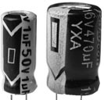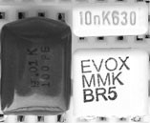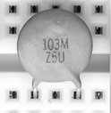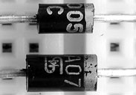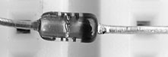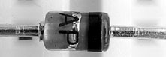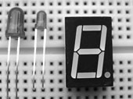

Class

Purpose

Symbol

Photograph

Fixed Resistor

Resistor

Limits flow of

current

Potentiometer

Resistor

Adjustable resistor

Light Dependent Resistor

General purpose

Resistor (LDR)

light sensor

Hardware

Push Button

Momentary switch

Normally Closed

PBNC

)

(

Momentary switch

Push Button

Hardware

Normally Open

)

(

PBNO

Single Pole

Simple open/

Hardware

Single Throw

close switch

(

SPST

)

Hardware

Controls single

Single Pole

Double Throw

connection one of

)

(

SPDT

two directions

Hardware

Matched control of

Double Pole

Double Throw

two individual

(

DPDT

)

connections in two

directions

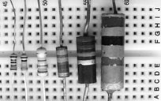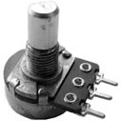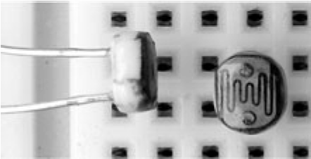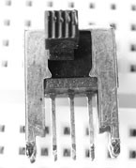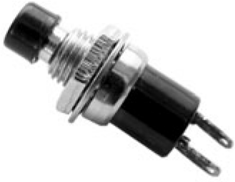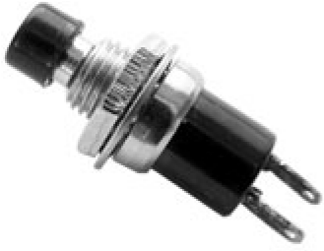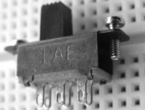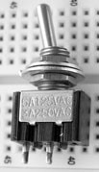

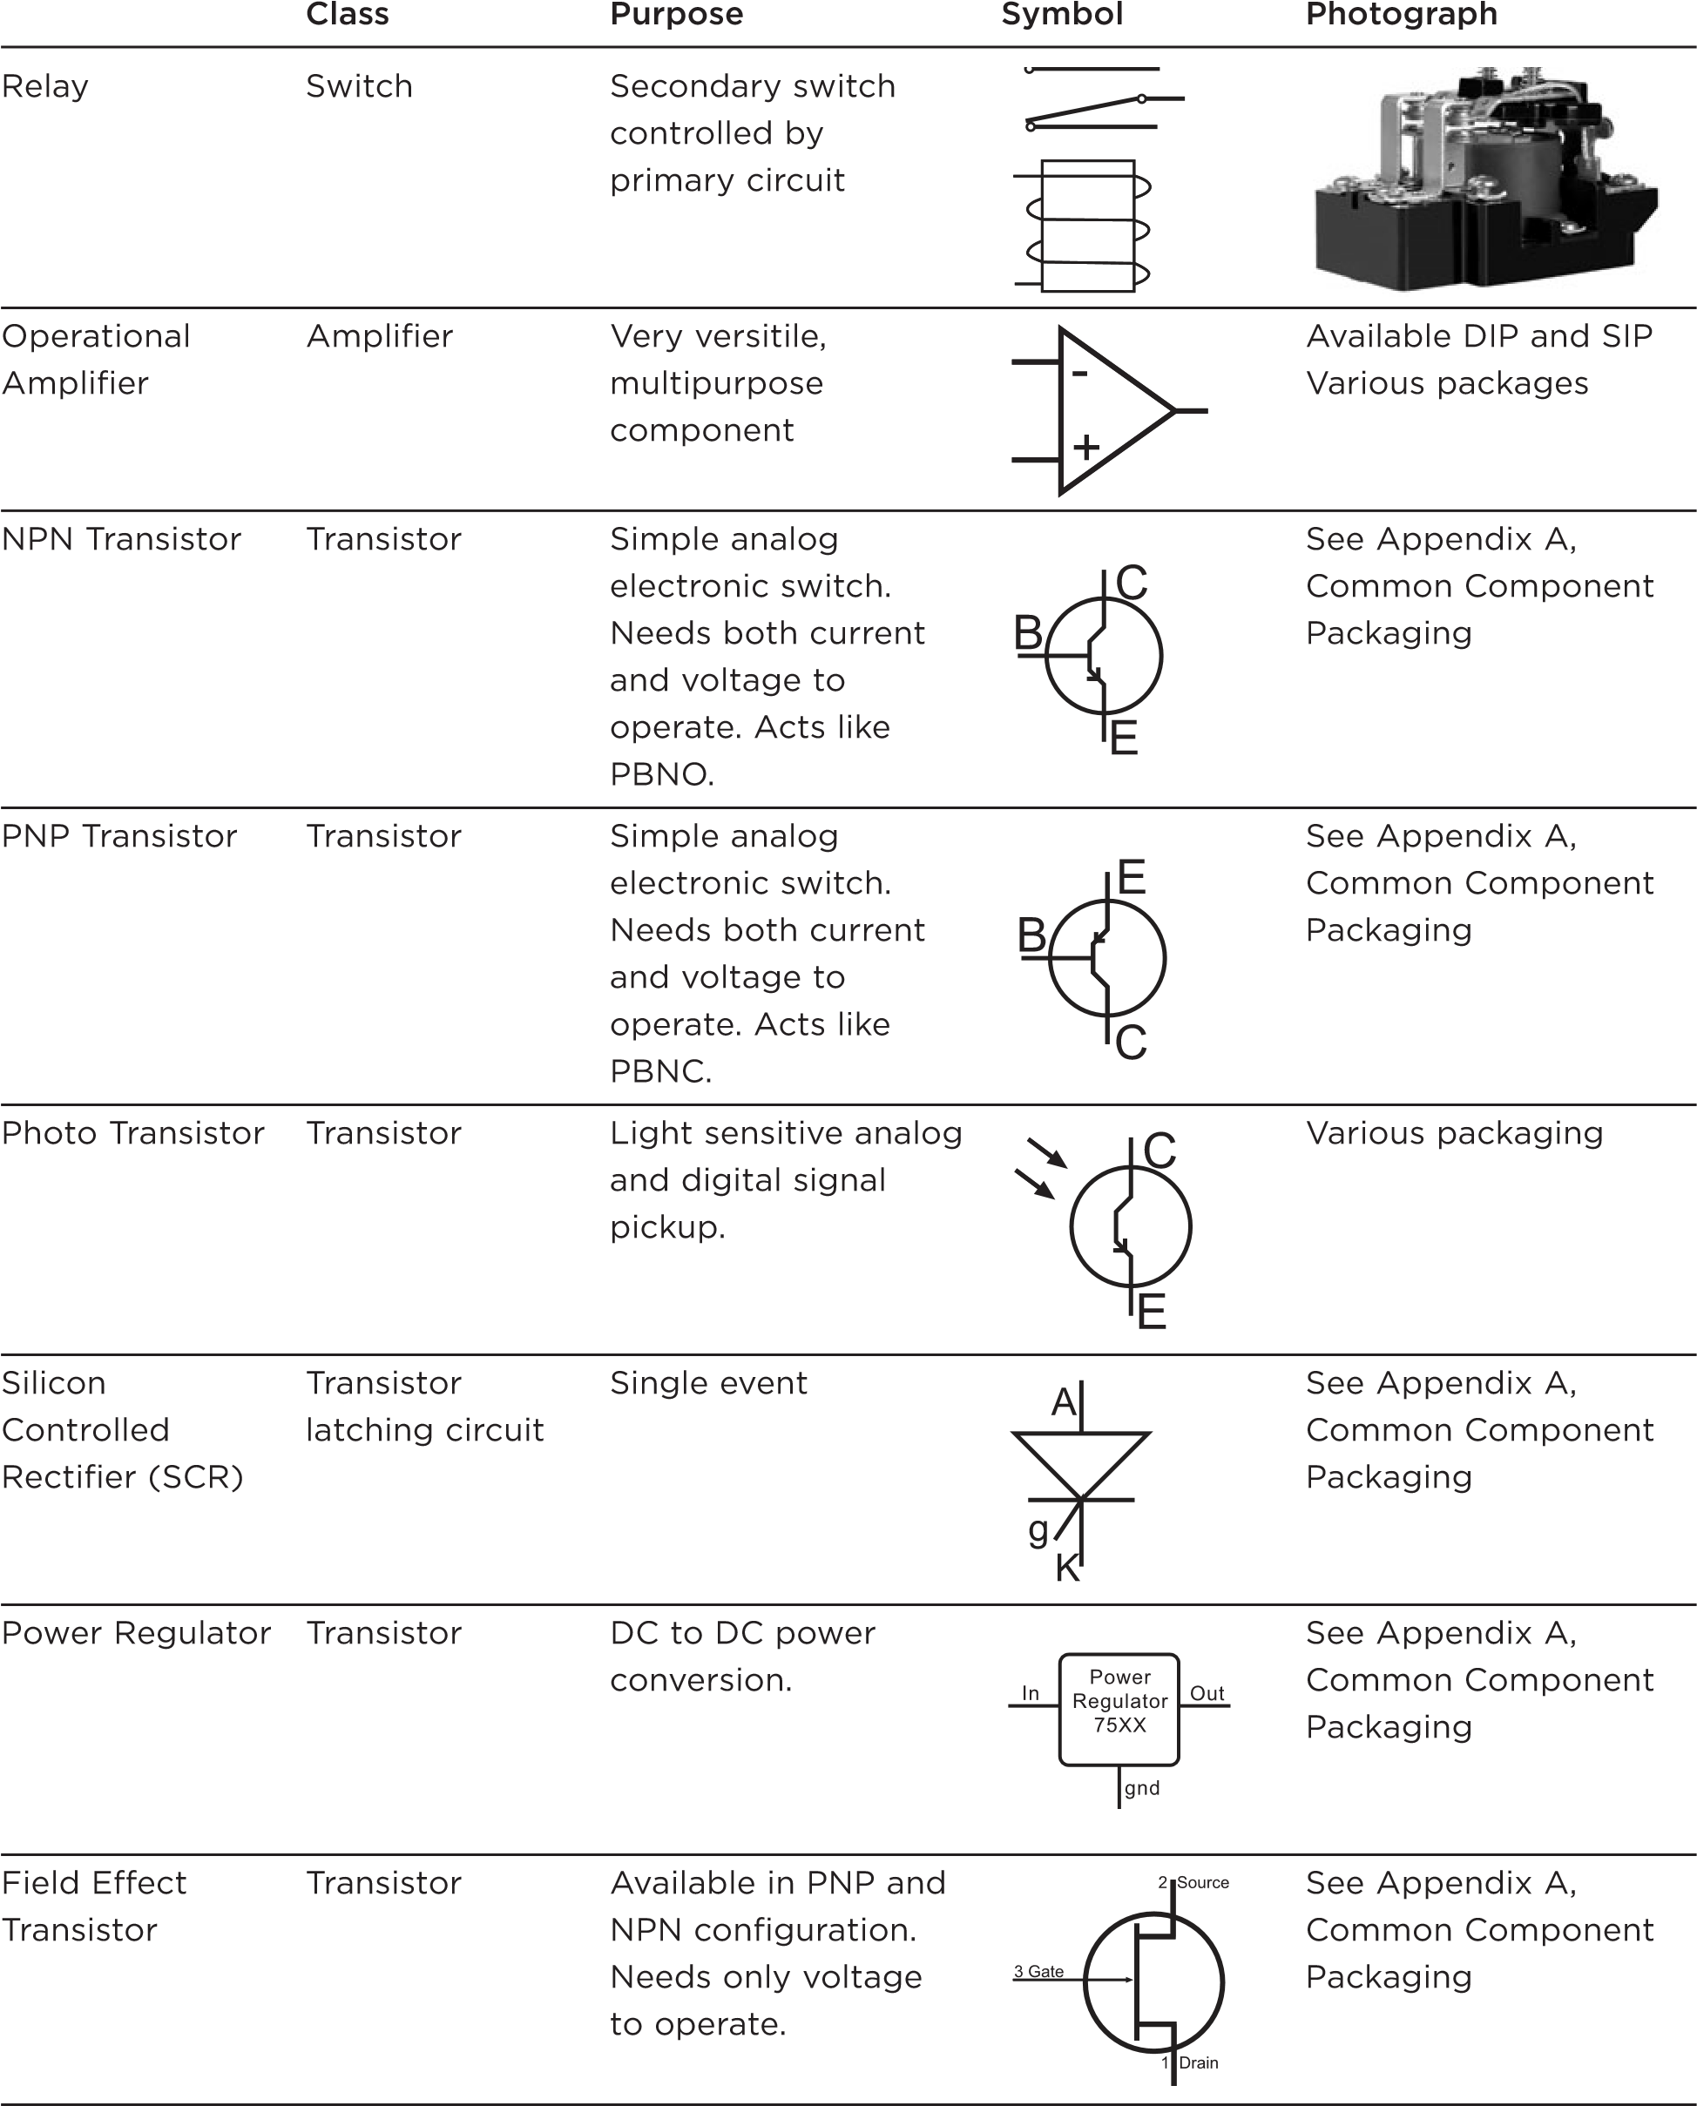

Class

Purpose

Symbol

Photograph

Sound pickup

Electret

Microphone

Microphone

Speaker

Speaker

Sound output

Used to isolate or

Transformer

Transformer

See Appendix A,

change AC voltage

Common Component

from a primary to

Packaging

secondary circuit.

InA InB Out

Logic Gate

AND Gate

H H H

H L L

L H L

L L L

Logic Gate

InA InB Out

OR Gate

H H H

H L H

L H H

L L L

Logic Gate

InA InB Out

NAND Gate

H H L

H

H L

L H

H

L L H

InA InB Out

Logic Gate

NOR Gate

H H L

H L L

L H L

L L H

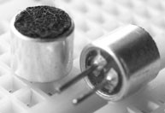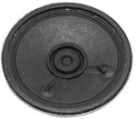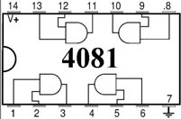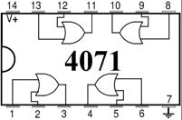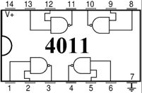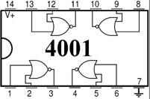

**Resistor Color Code**

|  |  |  |  |  |  |  |
| --- | --- | --- | --- | --- | --- | --- |
| **Color** | **Significant figures** | **Multiplier** | **Tolerance** | | **Temp. Coefficient (ppm/K)** | |
| Black | 0 | ×100 | – | | 250 | U |
| Brown | 1 | ×101 | ±1% | F | 100 | S |
| Red | 2 | ×102 | ±2% | G | 50 | R |
| Orange | 3 | ×103 | – | | 15 | P |
| Yellow | 4 | ×104 | (±5%) | – | 25 | Q |
| Green | 5 | ×105 | ±0.5% | D | 20 | Z |
| Blue | 6 | ×106 | ±0.25% | C | 10 | Z |
| Violet | 7 | ×107 | ±0.1% | B | 5 | M |
| Gray | 8 | ×108 | ±0.05% (±10%) | A | 1 | K |
| White | 9 | ×109 | – | | – | |
| Gold | – | ×10-1 | ±5% | J | – | |
| Silver | – | ×10-2 | ±10% | K | – | |
| None | – | – | ±20% | M | – | |

|  |  |  |  |  |  |  |  |  |
| --- | --- | --- | --- | --- | --- | --- | --- | --- |
| Color | | Significant digits | Multiplier | Capacitance tolerance | Characteristic | DC working voltage | [Operating temperature](http://en.wikipedia.org/wiki/Operating_temperature) | EIA/vibration |
|  | **Black** | 0 | 1 | ±20% | — | — | −55 °C to +70 °C | 10 to 55 Hz |
|  | **Brown** | 1 | 10 | ±1% | B | 100 | — | — |
|  | **Red** | 2 | 100 | ±2% | C | — | −55 °C to +85 °C | — |
|  | **Orange** | 3 | 1000 | — | D | 300 | — | — |
|  | **Yellow** | 4 | 10000 | — | E | — | −55 °C to +125 °C | 10 to 2000 Hz |
|  | **Green** | 5 | 100000 | ±0.5% | F | 500 | — | — |
|  | **Blue** | 6 | 1000000 | — | — | — | −55 °C to +150 °C | — |
|  | **Violet** | 7 | 10000000 | — | — | — | — | — |
|  | **Grey** | 8 | — | — | — | — | — | — |
|  | **White** | 9 | — | — | — | — | — | [EIA](http://en.wikipedia.org/wiki/Electronic_Industries_Alliance) |
|  | **Gold** | — | — | ±5%* | — | 1000 | — | — |
|  | **Silver** | — | — | ±10% | — | — | — | — |

**Capacitor Color Code**

**General Capacitance Code Breaker Chart**

|  |  |  |  |
| --- | --- | --- | --- |
| pico-farad (pF) | nano-farad (nF) | micro-farad (mF,uF or mfd) | capacitance code |
| 1000 | 1 or 1n | 0.001 | 102 |
| 1500 | 1.5 or 1n5 | 0.0015 | 152 |
| 2200 | 2.2 or 2n2 | 0.0022 | 222 |
| 3300 | 3.3 or 3n3 | 0.0033 | 332 |
| 4700 | 4.7 or 4n7 | 0.0047 | 472 |
| 6800 | 6.8 or 6n8 | 0.0068 | 682 |
| 10000 | 10 or 10n | 0.01 | 103 |
| 15000 | 15 or 15n | 0.015 | 153 |
| 22000 | 22 or 22n | 0.022 | 223 |
| 33000 | 33 or 33n | 0.033 | 333 |
| 47000 | 47 or 47n | 0.047 | 473 |
| 68000 | 68 or 68n | 0.068 | 683 |
| 100000 | 100 or 100n | 0.1 | 104 |
| 150000 | 150 or 150n | 0.15 | 154 |
| 220000 | 220 or 220n | 0.22 | 224 |
| 330000 | 330 or 330n | 0.33 | 334 |
| 470000 | 470 or 470n | 0.47 | 474 |

**Abbreviations**

|  |  |  |  |
| --- | --- | --- | --- |
| **Parameter** | **Symbol** | **Measuring Unit** | **Description** |
| Voltage | Volt | V or E | Unit of Electrical Potential **V = I × R** |
| Current | Ampere | I or i | Unit of Electrical Current **I = V ÷ R** |
| Resistance | Ohm | R or Ω | Unit of DC Resistance **R = V ÷ I** |
| Conductance | Siemen | G or ℧ | Reciprocal of Resistance **G = 1 ÷ R** |
| Capacitance | Farad | C | Unit of Capacitance **C = Q ÷ V** |
| Charge | Coulomb | Q | Unit of Electrical Charge **Q = C × V** |
| Inductance | Henry | L or H | Unit of Inductance **VL = -L(di/dt)** |
| Power | Watts | W | Unit of Power **P = V × I**  or  **I2 × R** |
| Impedance | Ohm | Z | Unit of AC Resistance **Z2 = R2 + X2** |
| Frequency | Hertz | Hz | Unit of Frequency **ƒ = 1 ÷ T** |

**Introduction to Electronic Design Automation**

Electronic design automation (EDA) is the category of tools for designing and producing electronic systems ranging from [printed circuit boards](http://www.exampleproblems.com/wiki/index.php?title=Printed_circuit_board&action=edit&redlink=1) (PCBs) to [integrated circuits](http://www.exampleproblems.com/wiki/index.php/Integrated_circuit). This is sometimes referred to as ECAD (electronic [computer-aided design](http://www.exampleproblems.com/wiki/index.php?title=Computer-aided_design&action=edit&redlink=1)).

The term *EDA* is also used as an umbrella term for [computer-aided engineering](http://www.exampleproblems.com/wiki/index.php?title=Computer-aided_engineering&action=edit&redlink=1), [computer-aided design](http://www.exampleproblems.com/wiki/index.php?title=Computer-aided_design&action=edit&redlink=1) and [computer-aided manufacturing](http://www.exampleproblems.com/wiki/index.php?title=Computer-aided_manufacturing&action=edit&redlink=1) of [electronics](http://www.exampleproblems.com/wiki/index.php/Electronics) in the discipline of [electrical engineering](http://www.exampleproblems.com/wiki/index.php/Electrical_engineering). This usage probably originates in the [IEEE](http://www.exampleproblems.com/wiki/index.php?title=IEEE&action=edit&redlink=1) Design Automation Technical Committee.

EDA has rapidly increased in importance with the continuous scaling of [semiconductor](http://www.exampleproblems.com/wiki/index.php/Semiconductor) technology. (See: [Moore's Law](http://www.exampleproblems.com/wiki/index.php?title=Moore%27s_Law&action=edit&redlink=1).) The largest segment of EDA users are chip designers at [semiconductor](http://www.exampleproblems.com/wiki/index.php/Semiconductor) companies, who design chips using EDA software. Other users are foundry operators, who operate the semiconductor fabrication facilities, or "fabs", and design-service companies who use EDA software to evaluate an incoming design for manufacturing readiness. EDA tools are also used for programming design functionality into [FPGAs](http://www.exampleproblems.com/wiki/index.php?title=FPGA&action=edit&redlink=1).

**Circuit Wizard**

Circuit Wizard Professional Edition is a reliable and straightforward utility that combines circuit and PCB designs, simulations and CAD / CAM manufacturers.  
  
Specially designed for electric engineers and for those who need to create or just simply analyze a circuit network, Circuit Wizard Professional Edition is worth having when you need to perform several simulations.  
  
By using Circuit Wizard Professional Edition you have the possibility to design your own circuit network or follow the circuit sketch from a building and analyze if there are any leaks.  
  
Therefore, designing circuit sketches becomes much easier using this utility. Just grab the components you need from the library, connect them together, then press the 'Play' button to start the simulation process. Because it features a complete and practical simulation engine, you can be confident that the results it delivers will be very fast and accurate.  
  
Moreover, Circuit Wizard Professional Edition boasts a library with simulated components, ranging from simple resistors to sophisticated circuits.  
  
The main window of the application is quite simple and does not require you to have advanced skills on how to construct a circuit network. In the right menu you have the possibility to access all the tools you are interested in such as power suppliers, connectors, semiconductors or logic gates.  
  
The utility allows you to create electronic circuit designs using various diagrams. Once drawn, these diagrams can be easily simulated and animated on-screen, allowing you to test and refine your circuit ideas.  
  
Alternatively, Circuit Wizard Professional Edition provides you with a range of various instruments designed for analyzing the performance of a PCB circuit and routing single-sided and double-sided boards.  
  
Also, by using this application you can produce a simple 'Bill of Materials' spreadsheet containing properties assigned to the components in your design. This way, you can handle your project costs and define the exact format of the report.  
  
Circuit Wizard Professional Edition is a complete and reliable electronics design solution that provides you with circuit diagrams and allows you to perform PCB simulations. All in one, the application suits novice and advanced users alike.

**Dual Voltage Power Supply (24V – 1A)**

**Schematic Diagram**

**Schematic Capture**

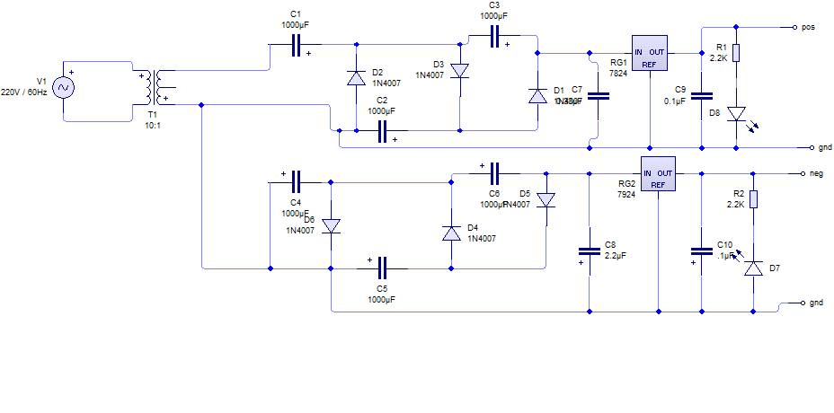

**PCB Layout**

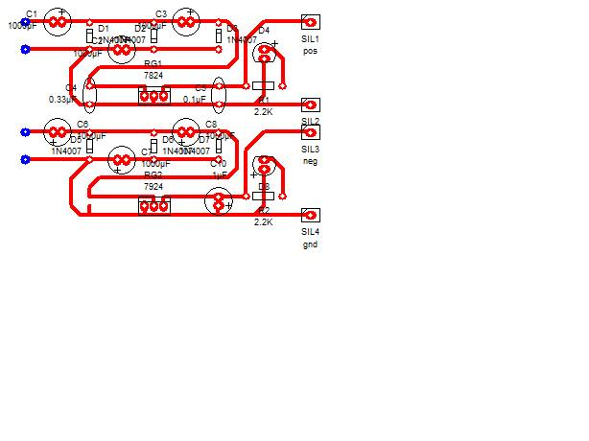

**Circuit Discussion**

Our 24V 1A Dual Voltage Power Supply uses a 220V/6V transformer to transform 220V AC to 6V AC, a Cockcroft–Walton Generator to generate 24V DC from a 6V AC, and LM7824/LM7924 to regulate 24V/-24V DC.

The Cockcroft–Walton (CW) generator, or multiplier, is an [electric circuit](http://en.wikipedia.org/wiki/Electric_circuit) that generates a high [DC](http://en.wikipedia.org/wiki/Direct_current) [voltage](http://en.wikipedia.org/wiki/Voltage) from a low voltage [AC](http://en.wikipedia.org/wiki/Alternating_current) or pulsing DC input. It was named after the British and Irish physicists [John Douglas Cockcroft](http://en.wikipedia.org/wiki/John_Douglas_Cockcroft) and [Ernest Thomas Sinton Walton](http://en.wikipedia.org/wiki/Ernest_Walton), who in 1932 used this circuit design to power their [particle accelerator](http://en.wikipedia.org/wiki/Particle_accelerator), performing the first artificial nuclear disintegration in history. They used this [voltage multiplier](http://en.wikipedia.org/wiki/Voltage_multiplier) cascade for most of their research, which in 1951 won them the [Nobel Prize in Physics](http://en.wikipedia.org/wiki/Nobel_Prize_in_Physics) for "Transmutation of atomic nuclei by artificially accelerated atomic particles". Less well known is the fact that the circuit was discovered much earlier, in 1919, by [Heinrich Greinacher](http://en.wikipedia.org/wiki/Heinrich_Greinacher), a Swiss [physicist](http://en.wikipedia.org/wiki/Physicist). For this reason, this doubler cascade is sometimes also referred to as the Greinacher multiplier. Cockcroft-Walton circuits are still used in particle accelerators, but now also in many everyday electronic devices that require high voltages, such as [x-ray machines](http://en.wikipedia.org/wiki/X-ray_machine), [television sets](http://en.wikipedia.org/wiki/Television_set), and [photocopiers](http://en.wikipedia.org/wiki/Photocopier).

[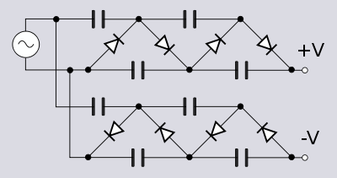](http://en.wikipedia.org/wiki/File:Stacked_Villard_cascade.svg)

LM78XX and LM79XXA

3-Terminal 1 A Positive and negative Voltage Regulator

Features :

Output Current up to 1 A

Output Voltages: 5, 6, 8, 9, 10, 12, 15, 18, 24, -5, -6, -8, -9, -10, -12, -15, -18, -24 V

Thermal Overload Protection

Short-Circuit Protection

Output Transistor Safe Operating Area Protection

Description:

The LM78XX and LM79xx series of three-terminal positive and negative regulators is available in the TO-220 package and with several fixed output voltages, making them useful in a wide range of applications. Each type employs internal current limiting, thermal shut-down, and safe operating area protection. If adequate heat sinking is provided, they can deliver over 1 A output current. Although designed primarily as fixed- voltage regulators, these devices can be used with external components for adjustable voltages and currents

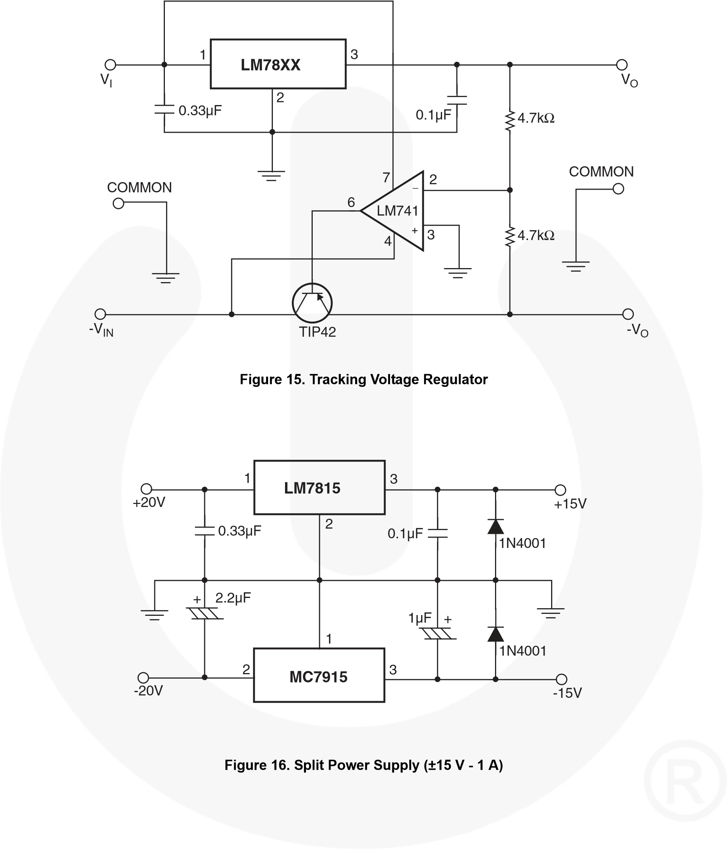

-24V

LM7829

LM7824

-27V

27V

24V

**Electronic Packaging**

** **

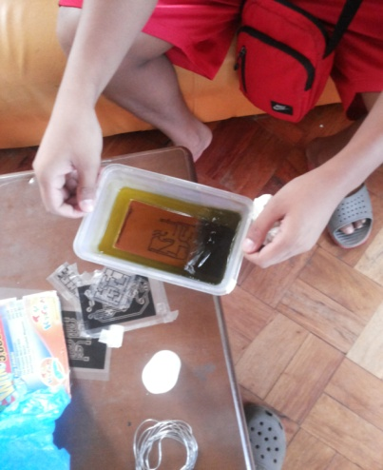 



**References**

Links:

http://www.exampleproblems.com/wiki/index.php/Electronic_design_automation

<http://www.softpedia.com/get/Science-CAD/Circuit-Wizard-Professional.shtml>

<http://www.allaboutcircuits.com/vol_3/chpt_3/8.html>

http://books.google.com.ph/books?id=mHRkTZvVnfUC&pg=PA22&lpg=PA22&dq=dual+polarity+voltage+doubler&source=bl&ots=i-jd0O9LoL&sig=zcOeWbEQu5cD2QE9B4xHPgjtiuQ&hl=en&sa=X&ei=b3MgU-LiNqidiAe8pIC4AQ&ved=0CCQQ6AEwADgK#v=onepage&q=dual%20polarity%20voltage%20doubler&f=false

http://www.augustica.com/full-wave-voltage-doubler-tripler-and-quadrupler-ezp-36

<http://en.wikipedia.org/wiki/Voltage_multiplier>

http://en.wikipedia.org/wiki/Cockcroft%E2%80%93Walton_generator

Datasheets:

Fair Child Semiconductors